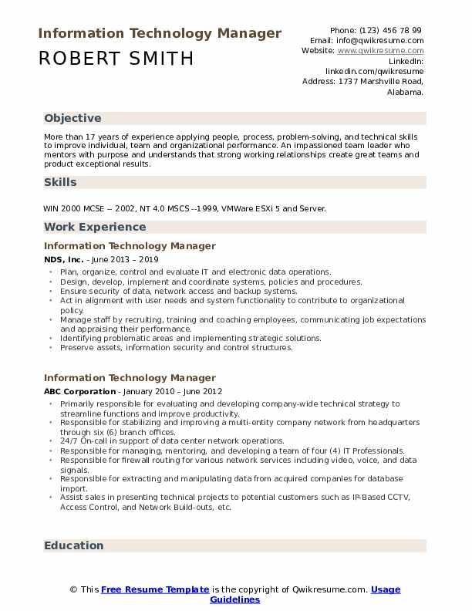
Information Technology Manager
ROBERT SMITH
Phone: (123) 456 78 99 Email: Info@qwikresume.com Website: www.qwikresume.com
Linkedin:
linkedin.com/qwikresume
Address: 1737 Marshville Road, Alabama.
Objective
More than 17 years of experience applying people, process, problem-solving, and technical skills to improve individual, team and organizational performance. An impassioned team leader who mentors with purpose and understands that strong working relationships create great teams and product exceptional results.
Skills
WIN 2000 MCSE 2002, NT 4.0 MSCS--1999, VMWare ESXi 5 and Server.
Work Experience
Information Technology Manager
NDS, Inc. - June 2013 - 2019
⚫Plan, organize, control and evaluate IT and electronic data operations.
• Design, develop, implement and coordinate systems, policies and procedures.
"
Ensure security of data, network access and backup systems,
Act in alignment with user needs and systern functionality to contribute to organizational policy.
Manage staff by recruiting, training and coaching employees, communicating job expectations and appraising their performance.
• Identifying problematic areas and implementing strategic solutions.
• Preserve assets, information security and control structures,
Information Technology Manager
ABC Corporation - January 2010 June 2012
.
Primarily responsible for evaluating and developing company-wide technical strategy to streamline functions and improve productivity.
Responsible for stabilizing and improving a multi-entity company network from headquarters through six (6) branch offices.
24/7 On-call in support of data center network operations.
Responsible for managing, mentoring, and developing a team of four (4) IT Professionals. Responsible for firewall routing for various network services including video, voice, and data signals.
⚫ Responsible for extracting and manipulating data from acquired companies for database import.
• Assist sales in presenting technical projects to potential customers such as IP Based CCTV, Access Control, and Network Build-outs, etc.
Education
© This Free Resume Template is the copyright of Qwikresume.com. Usage
Guidelines

